CUSTOMER COMPLAINT ANALYSIS

## PROJECT OVERVIEW
### This project analyzes consumer complaints against financial companies to identify customer issues, evaluate company response performance and uncover complaint trends across products, companies and states.
The analysis was performed using **Microsoft SQL Server** for data cleaning and business analysis, and **Power BI** for interactive visualizations.
---
## BUSINESS PROBLEMS
### 1. Why are customers raising complaints?
- Identify products with the highest complaints.
- Discover the most common complaint issues.
- Find companies receiving the most complaints.
- Analyze complaint trend over time.
### 2. Are companies responding efficiently?
- Measure timely response rate?
- Compare company timely response performance.
- Analyze company responses to customers.
- Evaluate complaint submission channels.
### 3. Which regions require more attention?
- Identify states with the highest complaint volume.
- Compare complaint distribution across the United States.
---

## tools used
- SQL Server
- Power BI
---

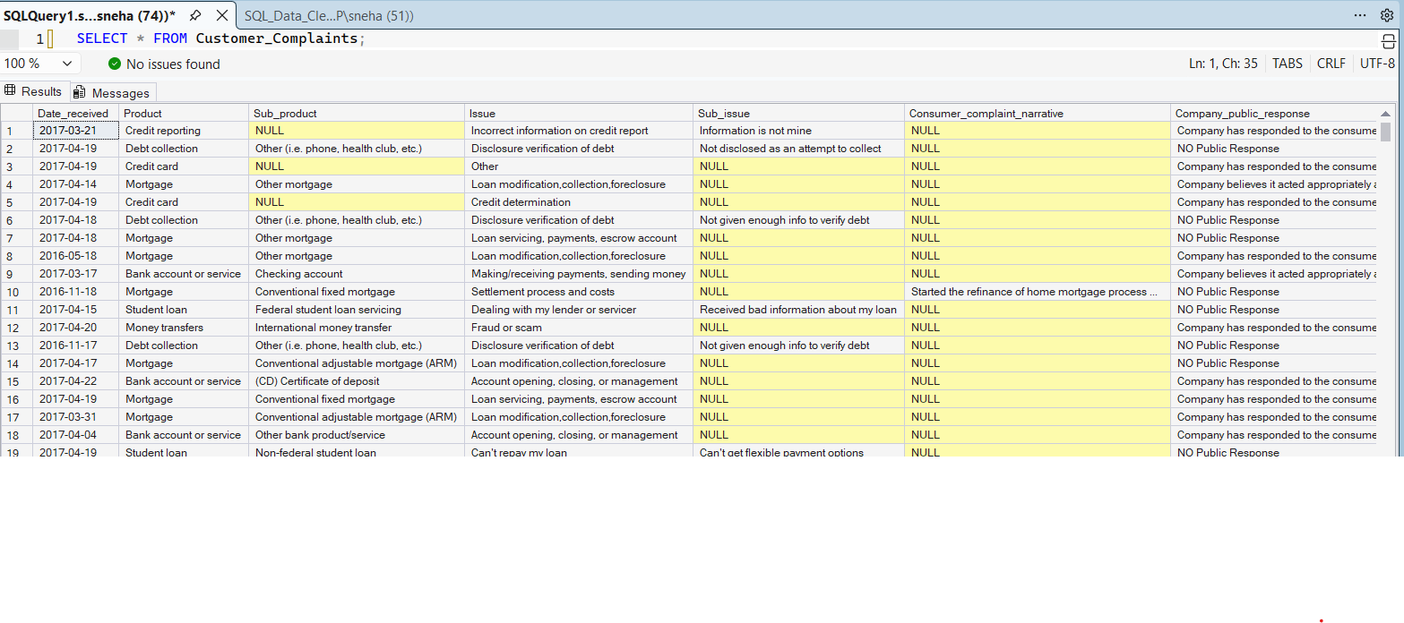
## Dataset Overview
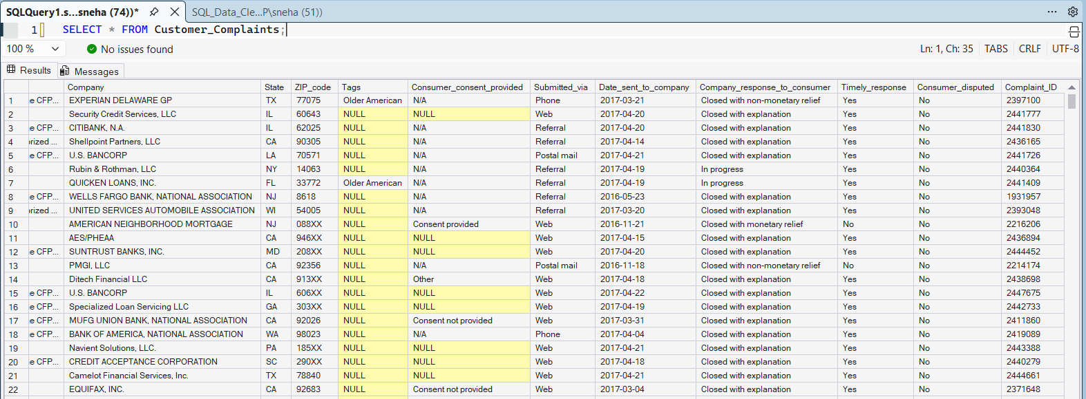

The dataset contains customer complaints related to financial products such as mortgages, credit cards, bank accounts, loans, debt collection and more.

## DATA CLEANING (SQL SERVER)
### The following data quality checks were performed: -
- Checked duplicate Complaint IDs
(using filter in group by having count >1)
- Checked missing values
(reviewed in each columns using IS NULL ())
- Replaced missing State with **Unknown**
- Replaced missing ZIP Codes with **Unknown**
- Replaced missing Company Public Response with **No Public Response**
- Retained missing values in Sub-product and Sub-issue were appropriate
- Removed leading/trailing spaces
- Standardized categorical values
(using DISTINCT ())
## excel
- Validate DATE fields
(using TEXT TO COLUMNS to change into date format)
---

## SQL BUSINESS ANALYSIS
### Measure taken to solve the business problem such as:
- Which products receive the most complaints?
- Which issue occur most frequently?
- Top 10 companies by complaint volume
- Complaint trend by year and month
- Complaint distribution by state
- Percentage of timely responses by company
- Complaint submission channel analysis
- Companies with the best response performance
- State-wises complaint ranking

---

## POWER BI DASHBOARD
## COMPLAINT OVERVIEW
## KPI Cards
- Total Complaints
- Total Products
- Total Companies
- Response in Progress
### Visualizations
- Complaints by product
- Top 10 Companies by complaint
- Top Issues
- Complaint Trend by Year and Month
- Complaint Distribution by State
### Interactive Filters
- Date received
- Submitted via
---

## SERVICE PERFORMANCE
### KPI Cards
- Timely Response%
- Customer Dispute %
- Total Companies

### Visualizations
- Complaint Submission Channel Distribution
- Company Response Distribution to Customers
- Quarterly Complaint Response Trend
- Timely Response by Company

### Interactive Filters
- Date Received
- Submitted via
- Company
---

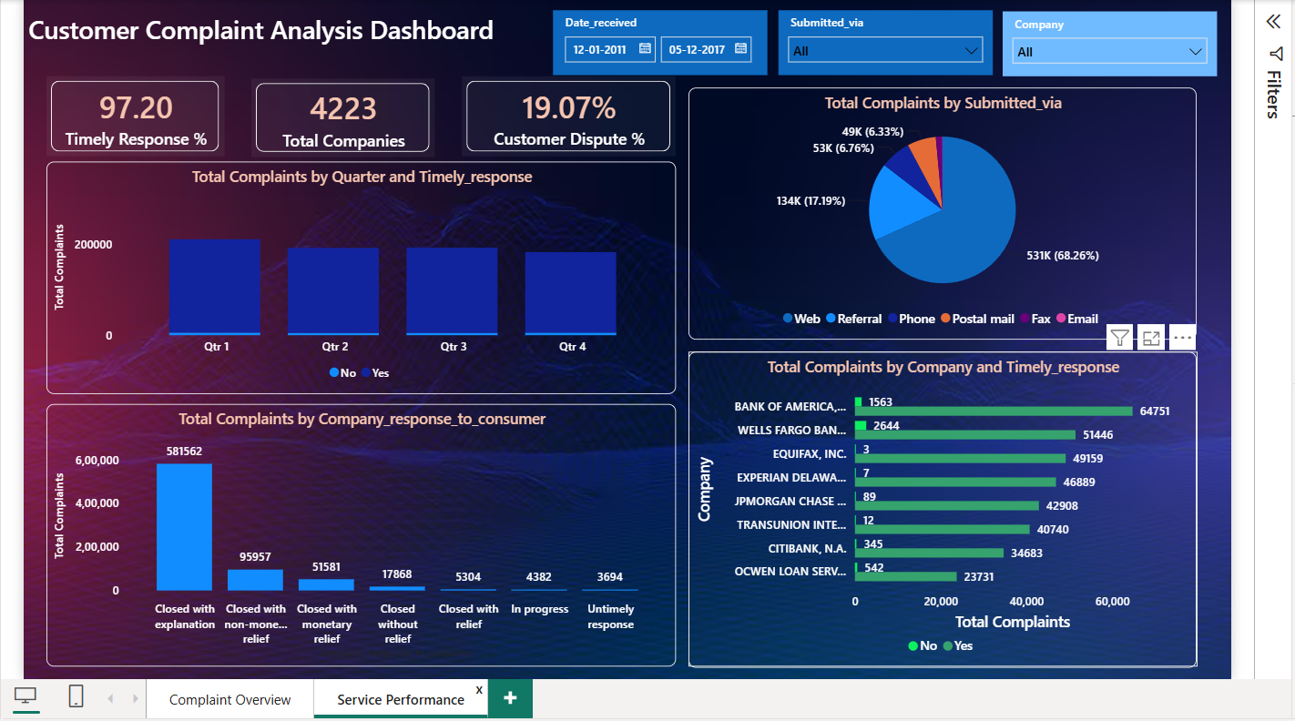
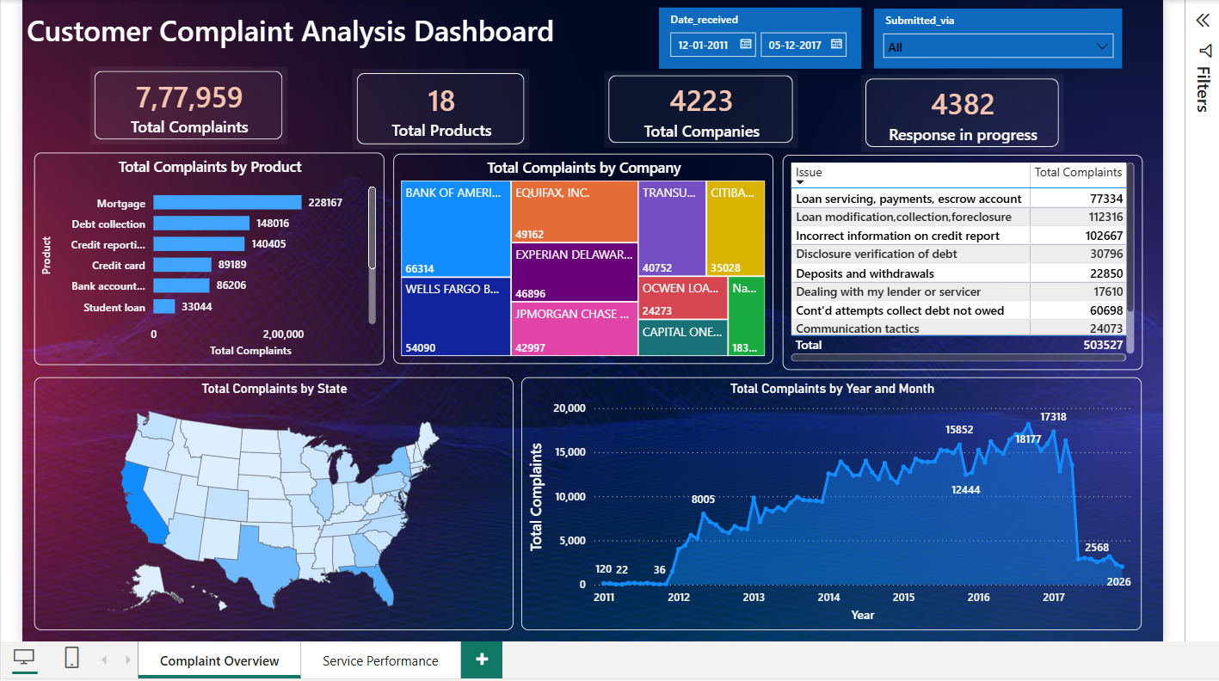
## Dashboard Preview
## KEY INSIGHTS
- Mortgage and Debt Collection generated the highest number of complaints.
- Most complaints were submitted through Web.
- Overall Timely Response was 97.20% indicating efficient response.
- Complaints volumes increased significantly from Oct 2015 to Jan 2017 and quite decline in May 2017 around 3000 number of complaints which shows the improvement by companies over time.
- The data indicated that more complaints received in CA State around 1,11,765 and TX 60400 and varied considerably across states.
- Most complaints received by BANK OF AMERICA, NATIONAL ASSOCIATION (66314) however most complaints were still responded timely around 97.64% and rest was in progress.
- Most complaints had common issues like Loan servicing, payments, incorrect information on credit report.
- However, the customer dispute rate was 19.07% Indicating that timely response do not always result in satisfactory resolutions.
- And Quarterly complaint volumes were decreasing overtime.
---

## RECOMMENDATIONS
- Prioritize improvements for products with the highest complaint volumes.
- Investigating recurring complaint issues to reduce customer dissatisfaction.
- Maintain hight timely response rates across all companies and look up for dispute complaints with proper disclosure.
- Improve customer communication for complaints that remain unresolved.
- Focus on customer support resources on high complaint states such as CA.
- Monitor complaint trends regularly to identify emerging issues early.

## Author - Sneha Sharma
LinkedIn: https://www.linkedin.com/in/12sneha-sharma/

